GUIDE TO FILING PATENT IN VIETNAM

When filing patent in Vietnam, it is necessary to know procedure, required documents to Vietnam patent entry including PCT Patent in Vietnam, direct patent.

How many type of patent in Vietnam?
In Vietnam, we have two types of patent including:
+ Patent for invention
+ Utility solution

What is criteria for patent to be protected in Vietnam?
A patent in Vietnam shall be protect if it meets the following conditions:
+ Novelty step
+ Inventive step (not applicable to utility solution)
+ Industrial applicability

What are priority claims of patent available in Vietnam?
A patent in Vietnam could be filed in one of the three types:
+ Direct filing: a foreign patent applicant could file their patent in Vietnam directly.
+ PCT Patent: 31 months from the first filing date.
+ Paris conventions: 12 months counted from the first filing date.

How long is validity of patent in Vietnam?
+ Patent for invention: 20 years from the filing date.
+ Patent for utility solution: 10 years from the filing date.
In order to maintain the validity of Vietnam patent, the annuity patent fee shall be payable annually after the patent is granted only.

What are required documents to file patent in Vietnam?
– Specification of the patent. If it is a PCT patent, we could download it from WIPO’s website.
– Claims of patent or amended claims, if any.
– Drawing (if any)
– Certified copy of priority document (if any)
– Name and Address of inventor and applicant.
– POA (drafted by ASL LAW): Sign only. A copy via email is acceptable, the original one shall be submitted later within 01 month from the filing date or 03 months to PCT patent.

Where can we file the patent in Vietnam?
The patent shall be filed at Vietnam National Office of Intellectual property (NOIP)

What is procedure of filing patent in Vietnam?

+ Step 1: Formality examination of patent
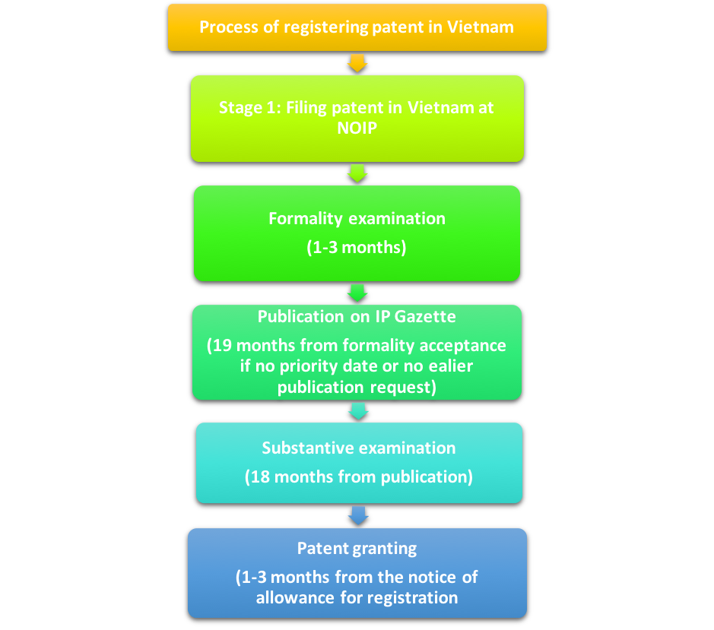 Process of registering patent in Vietnam – patent in Vietnam – PCT patent in Vietnam

National Office of Intellectual Property (NOIP) with examine the formality of the patent application within 1-2 months counted from the filing date. However, the actual time may be longer.

+ Step 2: Publication of patent on Vietnamese IP Gazette
NOIP shall publish the patent application on Vietnamese IP Gazette within 19 months counted from the first filing date or date of accepting its legitimate whatever comes later.
The applicant could ask for earlier publication of their patent application.

+ Step 3: Substantive examination of patent
NOIP shall issue the substantive examination result 18 months from the publishing date. If the result is positive, the patent shall be granted within 1-2 months. Otherwise, patent applicant shall have three months (extensible for 3 months) to respond to the rejection.

+ Step 4: Granting Vietnam patent
Within 1-3 months from the notice of patent granting.

What is sample of patent certificate in Vietnam?
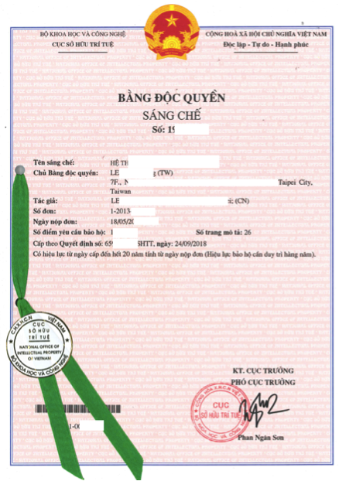
Patent in Vietnam – Vietnam Patent – PCT Patent in Vietnam – File Patent in Vietnam

Why choose ASL LAW?
In addition to other intellectual property services of ASL LAW, our patent service is a proper choice for clients due to the following factors:
Vietnam IP Firm – Vietnam Patent Firm – Vietnam Patent Attorney – Patent in Vietnam (ASL LAW)

– Budget saving: we provide affordable rate of translations of patent specification into different languages to help clients save their budget. We could provide translation of the following languages:
- Vietnamese to English, Japanese, Korean, Chinese, and Taiwanese.
- English to Khmer or Laos
– Specialized patent attorneys in different technical fields.
– Advanced technology to monitor patent’s portfolio.
– Flexible billing

